
AI-BASED VOICE COMPLAINT MANAGEMENT SYSTEM
A CAPSTONE PROJECT REPORT
A Capstone Project Report submitted in partial fulfilment of the requirements for the
Natural Language Processing

to the award of the degree of
BACHELOR OF TECHNOLOGY
IN
ARTIFICIAL INTELLIGENCE AND DATA SCIENCE
Submitted by
K. Deeksha Sree
192424097
Under the Supervision of
Dr T Kumaragurubaran
SIMATS ENGINEERING
Saveetha Institute of Medical and Technical Sciences
Chennai-602105
SEPTEMBER 2026

SIMATS ENGINEERING
Saveetha Institute of Medical and Technical Sciences
Chennai-602105
BONAFIDE CERTIFICATE
This is to certify that the Capstone Project entitled “AI-BASED VOICE COMPLAINT MANAGEMENT SYSTEM USING NATURAL LANGUAGE PROCESSING” has been carried out by K.Deeksha Sree (192424097) under the supervision of Dr T Kumaragurubaran
and is submitted in partial fulfilment of the requirements for the B.Tech Artificial Intelligence and Data Science programme at Saveetha Institute of Medical and Technical Sciences, Chennai.

SIGNATURE SIGNATURE
Dr T Kumaragurubaran Project Guide
Professor
Department of CSE Department of CSE
Saveetha School of Engineering Saveetha School of Engineering
SIMATS SIMATS

SIMATS ENGINEERING
Saveetha Institute of Medical and Technical Sciences
Chennai-602105
DECLARATION
I K. Deeksha Sree (192424097) of the B TECH AI&DS, SIMATS Engineering, Saveetha Institute of Medical and Technical Sciences, Chennai, hereby declare that the Capstone Project Work entitled “AI-BASED VOICE COMPLAINT MANAGEMENT SYSTEM USING NATURAL LANGUAGE PROCESSING” is the result of my own bonafide efforts. The work presented herein is original and has been carried out in accordance with academic integrity and engineering ethics. All sources, software, datasets, computational resources and AI-assisted resources used in the project have been appropriately acknowledged.

Place:
Date:

Signature of the Students with Name
K. Deeksha Sree
SIMATS ENGINEERING
Saveetha Institute of Medical and Technical Sciences
Chennai-602105
Individual Contribution Statement
Student Name / Register No. | Specific Responsibilities | Design & Development Contribution | Testing & Analysis Contribution | Report Contribution | Approx. Contribution (%)
K.Deeksha Sree (192424097) | Voice Complaint Management System | Developed voice input, speech-to-text, NLP processing, AI classification, routing and database workflow. | Tested transcription, classification, priority, routing, database and dashboard outputs. | Contributed to all chapters, module documentation, results, conclusion and final report. | 100%
— | — | — | — | — | —
— | — | — | — | — | —
— | — | — | — | — | —
Total | — | — | — | — | 100%

ABSTRACT
The AI-Based Voice Complaint Management System Using Natural Language Processing is designed to simplify the process of registering, understanding, classifying, routing and managing complaints. Instead of requiring users to type a complaint manually, the system accepts a voice complaint and converts the speech into text. Natural Language Processing techniques are then applied to clean and process the text, extract useful linguistic features and identify the complaint category.
The proposed system consists of four major modules: Voice Input and Speech-to-Text, NLP Text Processing and Feature Extraction, AI-Based Complaint Classification, and Complaint Routing, Report Generation and Database. The prototype interface demonstrates successful audio recording, voice-to-text conversion, complaint analysis, category prediction, confidence estimation, priority assignment, smart department routing and administrator-side complaint management.
The system can be used in public services, electricity and utility services, internet/telecom, municipal services, banking, education administration and customer support. Its objective is to reduce manual complaint handling, improve routing, organize complaint records and provide faster access to complaint status and reports.

TABLE OF CONTENTS
Sl. No | Title | Page No.
i | CERTIFICATE FROM THE SUPERVISOR | ii
ii | DECLARATION BY THE CANDIDATE | iii
iii | INDIVIDUAL CONTRIBUTION STATEMENT | iv
iv | ABSTRACT | v
v | LIST OF TABLES | vi
vi | LIST OF ABBREVIATIONS / SYMBOLS | vii
1 | CHAPTER 1: Introduction and Engineering Problem | 1
2 | CHAPTER 2: Literature Review and Existing Solutions | 4
3 | CHAPTER 3: Engineering Design & Trade-offs, Sustainability, Ethics, Safety, Risk & Security | 7
4 | CHAPTER 4: Implementation, Testing & Results, Project Management | 13
5 | CHAPTER 5: Conclusion & Reflection | 18
 | References | 20
 | Appendices | 21
 | Capstone Project Outcome Mapping Sheet | 22

LIST OF TABLES
Table No. | Table Name | Page No.
2.1 | Comparative analysis of existing complaint approaches | 5
3.1 | Stakeholder requirements | 7
3.2 | Functional and non-functional requirements | 7
3.3 | Applicable standards and codes | 8
3.4 | Design specifications | 8
3.5 | Evaluation matrix for alternative solutions | 9
3.6 | Trade-off analysis | 11
3.7 | Sustainability, ethics, safety and security considerations | 12
3.8 | Risk register | 12
4.1 | Resources used | 13
4.2 | Tools and software used | 14
4.3 | Test plan and verification | 14
4.4 | Sample test results | 15
4.5 | Achievement of objectives | 16
4.6 | Project milestones | 17
4.7 | Team responsibilities | 17
4.8 | Cost estimate | 17

LIST OF ABBREVIATIONS / SYMBOLS
Symbol | Description | Unit
NLP | Natural Language Processing | —
AI | Artificial Intelligence | —
STT | Speech-to-Text | —
TF-IDF | Term Frequency–Inverse Document Frequency | —
ML | Machine Learning | —
GUI | Graphical User Interface | —

CHAPTER 1
INTRODUCTION AND ENGINEERING PROBLEM
1.1 Background
Complaint management is an important activity in government offices, utility services, educational institutions, organizations and customer-support environments. Traditional complaint systems commonly depend on manual forms, emails, telephone calls handled by staff, or separate departmental records. These approaches can require additional human effort and may make classification, routing, tracking and reporting difficult.
Voice interfaces and Natural Language Processing provide an opportunity to automate the first stages of complaint management. A user can speak a complaint naturally, after which the system converts the speech into text and analyzes the language. The resulting information can be used to classify the complaint and route it to the relevant department.
1.2 Need for the Project
Typing long complaints can be inconvenient for users.
Manual complaint classification consumes staff time.
Complaints may be routed to the wrong department.
- Large complaint volumes are difficult to organize manually.
- Priority identification may be inconsistent.
- Manual report preparation requires additional effort.
1.3 Problem Statement
- There is a need for an intelligent complaint-management system that can accept voice input, convert speech to text, understand the complaint using NLP, classify it into a suitable category, assign a priority, route it to the appropriate department, and store the complaint for future tracking and reporting.
1.4 Project Aim
- The aim of the project is to design and develop an AI-based voice complaint management system that combines speech-to-text conversion, NLP, machine-learning-based complaint classification, intelligent department routing, database management and report generation.
1.5 Project Objectives
Capture a user's complaint through a microphone.
Convert the recorded speech into text.
Preprocess complaint text using NLP techniques.
Extract relevant text features for AI classification.
Classify complaints into service categories.
Estimate complaint priority and classification confidence.
Automatically route complaints to the appropriate department.
- Store complaint details and status in a structured database.
- Provide an administrator dashboard for monitoring and updating complaints.
- Generate complaint summaries and reports.
- 1.6 Scope
- Included
- Voice-based complaint registration.
- Speech-to-text conversion.
- NLP preprocessing and feature extraction.
AI-based category classification.
Priority assignment and confidence display.
- Department routing.
- Complaint database and status management.
- Administrative dashboard and summary reporting.
- Excluded
- Fully autonomous resolution of every complaint.
- Large-scale deployment without additional infrastructure.
- Collection of unnecessary personal information.
- Assumptions and Boundary Conditions
- The user provides a reasonably clear voice recording.
The speech-to-text service or component is available.
- The classification model has been trained using representative complaint data.
- The database is available during complaint submission.
- 1.7 Expected Engineering Outcome
- The expected outcome is a working prototype that transforms a spoken complaint into a structured complaint record and displays the transcribed complaint, predicted category, confidence, priority, assigned department and stored status.

CHAPTER 2
LITERATURE REVIEW AND EXISTING SOLUTIONS
2.1 Review Method
The project considers existing approaches to complaint management, speech recognition, Natural Language Processing, text classification, ticket routing and database-supported service management. The review focuses on the engineering requirements needed to connect these technologies into one practical workflow.
2.2 Review of Existing Work
Manual Complaint System
Manual complaint systems use registers, written forms or staff-recorded information to capture complaints.
Advantages:
- Simple to implement.
- Does not require specialized AI technology.
- Easy for staff to understand.
Limitations:
- Time-consuming.
- Human classification errors are possible.
- Routing depends on staff availability.
- Records are difficult to analyze at large scale.
Web / Email Complaint System
Web forms and email allow users to submit digital complaints that can be stored electronically.
Advantages:
- Digital records can be maintained.
- Searching and retrieval are easier.
Limitations:
- Users must type the complaint.
- Manual reading and classification may still be required.
- Voice-Based Complaint Processing
Voice-based systems allow users to describe an issue naturally. Speech-to-text technology converts spoken language into a textual representation that can be processed by NLP techniques, creating a bridge between conversational input and automated complaint analysis.
NLP-Based Complaint Classification
NLP classification systems commonly perform text normalization, tokenization, removal of unnecessary words, feature extraction and supervised classification. Features such as TF-IDF vectors can represent important words and phrases numerically, allowing machine-learning algorithms to distinguish complaint categories.
- 2.3 Comparative Analysis
- Table 2.1 Comparative analysis of existing complaint approaches
2.4 Research / Engineering Gap
- Existing complaint approaches either depend heavily on manual interaction or separate the submission, classification and routing activities. The engineering gap is an integrated workflow that accepts voice input, converts speech to text, processes the language, classifies the complaint, assigns priority, routes it and stores it for monitoring.
2.5 Proposed Contribution
- The proposed system integrates voice input, speech-to-text, NLP analysis, AI classification, priority estimation, department routing, database storage and administrative reporting into a single pipeline. The main contribution is a voice-to-action complaint workflow that converts an unstructured spoken problem into a structured service record.
Existing Approach | Advantages | Limitations | Relevance to Proposed Work
Manual Complaint | Simple, low cost | Time-consuming, manual classification | Baseline
Web / Email | Digital records | Requires typing and manual review | Alternative
Voice + AI | Natural interaction, automated analysis | Depends on speech/model accuracy | Proposed system
Call Centre | Human interpretation | High staff effort | Alternative

CHAPTER 3

ENGINEERING DESIGN & TRADE-OFFS, SUSTAINABILITY, ETHICS, SAFETY, RISK & SECURITY
3.1 Requirements
Stakeholder / User Requirements
Stakeholder | Requirement
User | Submit complaint using voice
Administrator | Monitor and update complaints
Department | Receive correctly routed complaints
Management | View summaries and reports
Table 3.1 Stakeholder requirements
Functional & Non-Functional Requirements
Requirement | Type (Functional / Non-Functional)
Record voice complaint | Functional
Convert speech to text | Functional
Edit transcribed complaint | Functional
Preprocess complaint text | Functional
Extract NLP features | Functional
Classify complaint category | Functional
Assign priority/confidence | Functional
Route complaint to department | Functional
Store complaint in database | Functional
Update complaint status | Functional
Generate summaries/reports | Functional
Accuracy | Non-Functional
Reliability | Non-Functional
Usability | Non-Functional
Security and privacy | Non-Functional
Table 3.2 Functional and non-functional requirements
3.2 Constraints & Applicable Standards
The system depends on microphone quality, speech recognition performance, training-data quality, network availability where an external speech service is used, database availability and secure handling of complaint information.
- Table 3.3 Applicable standards and codes
- 3.3 Design Specifications
- Table 3.4 Design specifications
- System Workflow
- Voice Input → Speech-to-Text → NLP Processing → Feature Extraction → AI Classification → Priority Estimation → Department Routing → Database → Dashboard / Reports
- Module 1 – Voice Input and Speech-to-Text
The microphone captures the complaint as an audio signal. A speech-recognition component converts the audio into text, and the transcribed complaint is displayed so that the user can review or edit it before analysis.
Module 2 –

zNLP Text Processing and Feature Extraction
The transcribed text is normalized, tokenized and cleaned. Feature extraction such as TF-IDF converts the processed complaint into numerical features for the classifier.
Module 3 – AI-Based Complaint Classification
A trained machine-learning classifier predicts the complaint category from the extracted text features and returns a confidence value when supported. Priority can be assigned using the project’s decision rules.
Parameter | Target / Requirement
Voice Input | Clear audio capture
Speech-to-Text | Readable complaint transcription
NLP | Clean and normalized text
Feature Extraction | Numerical representation
Classification | Service category prediction
Confidence | Model confidence displayed where supported
Routing | Validated category-to-department mapping

Module 4 – Complaint Routing, Report Generation and Database
The predicted category is mapped to the responsible department. Complaint details, category, priority, confidence, department, date/time and status are stored in a database and displayed through the administrator dashboard.
3.4 Evaluation of Alternatives
Criterion | Alternative 1 (Manual) | Alternative 2 (Web/Email) | Alternative 3 (Voice + AI)
Automation | Low | Medium | High
Typing effort | High | High | Low
Natural interaction | Low | Medium | High
Automated classification | No | Optional | Yes
Routing support | Manual | Manual/Rule-based | AI + Rule-based
Scalability | Low | Medium | High
Table 3.5 Evaluation matrix for alternative solutions
Voice input is selected because it reduces typing effort and supports natural complaint description.
NLP-based classification is selected to automate category prediction.
A structured database is selected for searchable records, status management and reporting.
3.5 Integrated System Design
The four modules operate as a single pipeline. Module 1 supplies text to Module 2, the processed features are passed to Module 3, and the classification result is consumed by Module 4 for routing and storage. The dashboard reads structured complaint information from the database.
- 3.6 Trade-off Analysis
- Table 3.6 Trade-off analysis
- 3.7 Sustainability, Ethics, Safety, Risk & Security
- Digital complaint records reduce dependence on paper forms. Voice recordings and transcripts should be used only for legitimate complaint processing. Only required personal information should be collected. Access to complaint records should be limited to authorized users. Regular database backups reduce data-loss risk.
- Speech recognition should be tested under realistic noise conditions. Low-confidence or sensitive cases can be flagged for human verification. The system should not claim certainty when the model confidence is low.
- Table 3.7 Sustainability, ethics, safety and security considerations
- 3.8 Risk Register
Table 3.8 Risk register
- Key risks include background noise, speech-recognition errors, incorrect category prediction, incorrect department routing, duplicate complaints, data loss and unauthorized access. Mitigation includes transcript editing, model improvement, validated routing rules, unique complaint identifiers, backups and access control.

Design Decision | Alternative Considered | Benefit | Disadvantage | Final Decision & Justification
Voice Input | Typed-only input | Natural interaction | Noise/accent sensitivity | Voice input selected to reduce typing effort.
NLP Classification | Manual classification | Fast categorization | Depends on training data | AI classification selected for automation.
TF-IDF Features | Raw text only | Simple and efficient | Limited deep semantics | Suitable baseline feature representation.
Automated Routing | Manual routing | Reduces staff effort | Wrong prediction can misroute | Use validated category-to-department rules.

Domain | Consideration | Evidence Evaluated | Impact on Final Decision
Sustainability | Digital records reduce paper | Paper use vs digital storage | Selected database-backed workflow.
Ethics | Voice data requires purpose limitation | Privacy and access requirements | Collect only necessary information.
Safety | Recognition uncertainty can affect routing | Confidence and human review | Allow review of low-confidence cases.
Security | Complaint records require protection | Authentication, access control, backups | Restrict access and protect stored data.

Risk | Likelihood | Severity | Mitigation
Background noise | Medium | Medium | Clear recording conditions and preprocessing
Speech recognition error | Medium | Medium | Allow transcript editing
Incorrect category | Medium | High | Improve training data and confidence thresholds
Incorrect department routing | Medium | High | Validate category-to-department mapping
Duplicate complaint | Medium | Medium | Complaint identifiers and database checks
Data loss | Low | High | Regular database backups

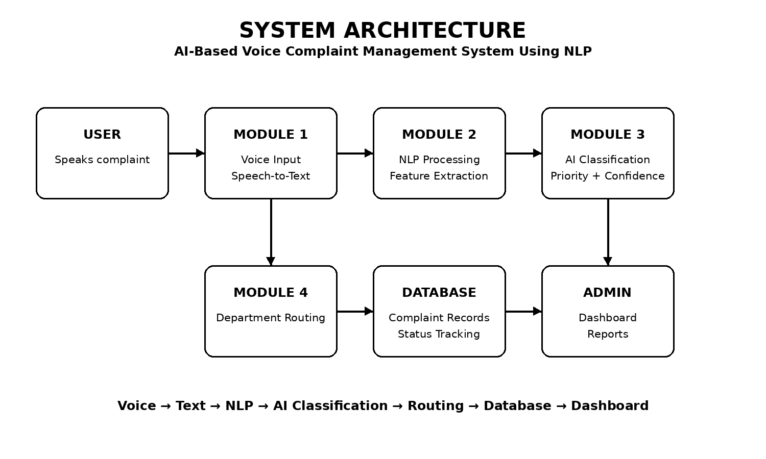
CHAPTER 4
IMPLEMENTATION, TESTING & RESULTS, PROJECT MANAGEMENT
4.1 Development Approach & Resources
The system is developed using a modular approach. Development begins with voice recording and speech-to-text conversion, followed by NLP preprocessing and feature extraction. The classification model predicts the complaint category. The routing and database module stores the result and makes it available through the administrator dashboard.
Resources Used
Resource | Purpose
Computer / Laptop | System development and testing
Microphone | Voice complaint capture
Python environment | Application development
Speech-to-text component | Voice transcription
NLP libraries | Text processing and feature extraction
Database | Complaint storage and status management
Table 4.1 Resources used
4.2 Software Implementation & Modern Tools Used
Implementation Process
- Open the complaint recording interface.
- Record the user's complaint using the microphone.
- Convert the audio into text.
- Display and optionally edit the transcribed complaint.
- Preprocess the complaint using NLP.
- Extract text features.
- Run the trained AI classification model.
- Display category, confidence and priority.
- Map the category to the appropriate department.
- Store the complaint and status in the database.
Tool / Software / Equipment | Purpose | Stage Used
Python | Application development | All stages
Speech Recognition / STT | Voice transcription | Module 1
NLP library | Preprocessing and features | Module 2
Scikit-learn / ML library | Classification | Module 3
Database system | Storage and status | Module 4
Web / GUI framework | User interface and dashboard | Module 4
Display the record on the administrator dashboard.
Generate complaint summaries and reports.
Requirement | Test Method | Acceptance Criterion
Voice input | Microphone recording test | Audio captured successfully
Speech-to-text | Spoken complaint test | Complaint converted to text
Transcript editing | Edit text and submit | Updated text accepted
NLP processing | Submit complaint text | Text processed successfully
Classification | Known category test | Category predicted
Confidence | Classification test | Confidence displayed
Priority | Complaint analysis test | Priority displayed
Table 4.2 Tools and software used
4.3 Test Plan & Verification
Specification | Required Value | Achieved Value | Status (Pass/Fail)
Voice recording | Audio captured | Audio recorded successfully | Pass
Speech-to-text | Text generated | Voice converted successfully | Pass
Complaint text | Text displayed | “light is not working” displayed | Pass
Classification | Electricity category | Electricity | Pass
Confidence | Confidence shown | 65.0% | Pass
Priority | Priority shown | Medium | Pass
Routing | Electrical Department | Electrical Department | Pass
Table 4.3 Test plan and verification
Sample Test Results
Table 4.4 Sample test results
4.4 Results
The supplied prototype screenshots demonstrate the complete flow from voice complaint recording to AI analysis and administrative management. In the first output, audio is recorded successfully and converted to the complaint text “light is not working.” In the analysis output, the system identifies Electricity as the category, displays 65.0% confidence, assigns Medium priority and routes the complaint to the Electrical Department. The administrator dashboard displays complaint records with category, department, priority, confidence and status.
- Key Results
- Voice recording completed successfully.
- Voice-to-text conversion completed successfully.
- Complaint text was displayed for review.
- Electricity category was predicted.
- Confidence was displayed as 65.0%.
- Priority was displayed as Medium.
Electrical Department was assigned.
Complaint information was displayed in the administrator dashboard.
4.5 Data Analysis & Engineering Judgment
System performance is influenced by speech clarity, background noise, training-data quality, text representation, classification accuracy and category-to-department mapping. Allowing the user to review or edit the transcribed complaint provides an additional control before AI analysis.
4.6 Comparison with Existing Solutions & Achievement of Objectives
Objective | Evidence | Achievement (Fully / Partially / Not Achieved)
Capture voice complaint | Microphone recording | Fully Achieved
Convert speech to text | Successful transcription | Fully Achieved
Process complaint text | NLP processing stage | Fully Achieved
Classify complaints | Electricity category output | Fully Achieved
Assign priority/confidence | Medium / 65.0% output | Fully Achieved
Route complaints | Electrical Department output | Fully Achieved
Store/manage records | Administrator dashboard | Fully Achieved
Table 4.5 Achievement of objectives
The proposed system improves on manual complaint workflows by reducing typing, automating classification and routing, and providing structured status monitoring. Human review remains important for uncertain predictions and exceptional cases.
4.7 Strengths & Limitations
- Strengths:
- Voice-based and user-friendly registration.
- Automatic speech-to-text conversion.
- NLP-based complaint understanding.
- Automated category and priority prediction.
- Smart department routing.
- Centralized complaint records.
- Administrator dashboard and status management.
Limitations:
- Speech recognition can be affected by noise or accents.
- Classification depends on training-data quality and coverage.
- Low-confidence predictions may require human verification.
- Incorrect classification can cause incorrect routing.
- Voice and complaint data require privacy and security controls.
4.8 Project Planning, Roles & Budget
Project Milestones
Phase | Activity
Phase 1 | Problem identification
Phase 2 | Literature review
Phase 3 | Requirements and system design
Phase 4 | Voice and speech-to-text module
Phase 5 | NLP and feature extraction
Phase 6 | AI classification and routing
Phase 7 | Database and dashboard integration
Phase 8 | Testing and debugging
Phase 9 | Results and documentation
Phase 10 | Final review and submission
Table 4.6 Project milestones
Team Responsibilities
Student | Assigned Responsibility | Actual Contribution
K.Deeksha Sree | Complete System – Modules 1 to 4 | Developed voice input, speech-to-text, NLP processing, AI classification, department routing, database, dashboard, testing and documentation.
— | — | —
— | — | —
— | — | —
Table 4.7 Team responsibilities

CHAPTER 5
CONCLUSION, FUTURE WORK AND REFLECTION
5.1 Conclusion
The AI-Based Voice Complaint Management System Using Natural Language Processing provides an automated workflow for collecting and managing complaints. The system combines voice input, speech-to-text conversion, NLP processing, feature extraction, AI-based classification, priority assignment, department routing, database management and an administrator dashboard.
The supplied prototype outputs demonstrate that a spoken complaint can be converted into text, analyzed as Electricity with a displayed confidence of 65.0%, assigned Medium priority, routed to the Electrical Department and managed through an administrative dashboard. This integrated workflow can reduce manual complaint handling and improve organization of complaint records.
5.2 Future Work
Improve speech recognition for different accents and noisy environments.
Support multiple Indian and regional languages.
- Use transformer-based NLP models for deeper semantic understanding.
- Improve classification with a larger and more diverse complaint dataset.
- Add automatic duplicate and similar-complaint detection.
- Add SMS/email/app notifications for complaint status updates.
- Provide complaint tracking for users.
- Add advanced analytics and department performance dashboards.
- Deploy the system on cloud infrastructure for large-scale use.
- Strengthen privacy, authentication, audit logs and data protection.
- 5.3 Professional Learning & Individual Reflection
- New Knowledge Acquired:
Learned practical applications of speech recognition and Natural Language Processing.
Gained experience with text preprocessing and feature extraction.
- Learned machine-learning-based complaint classification.
- Learned database-supported complaint management.
- Understood the integration of AI modules into a complete application.
- Engineering & Professional Skills Developed:
- Python programming.
Natural Language Processing.
- Machine learning.
- Database management.
- System design and integration.
- Testing and debugging.
- Technical documentation.
- Individual Reflection
- During the project, the major engineering challenge was integrating speech-to-text, NLP, classification, routing and database components into a single reliable workflow. The project required attention to input quality, feature representation, model confidence and human verification.
A key engineering decision was to allow the user to review the transcribed complaint before analysis. This provides a practical control against speech-recognition errors. The project provided experience in developing a complete AI-enabled application from problem identification through implementation and testing.

REFERENCES
References are presented in IEEE-style form. The following sources support the speech recognition, Natural Language Processing, information retrieval and machine-learning aspects of the project.

1. Speech and Language Processing
Jurafsky, D. and Martin, J. H., Speech and Language Processing, Pearson / draft editions.
This reference supports concepts in speech recognition, language processing and text classification.
2. Introduction to Information Retrieval

Manning, C. D., Raghavan, P. and Schütze, H., Introduction to Information Retrieval, Cambridge University Press.
This reference supports text representation, information retrieval and TF-IDF concepts.
3. Natural Language Processing with Python
Bird, S., Klein, E. and Loper, E., Natural Language Processing with Python, O’Reilly Media.

This reference supports practical NLP preprocessing and text-processing workflows.
4. Attention Is All You Need
Vaswani, A. et al., “Attention Is All You Need,” Advances in Neural Information Processing Systems, 2017.
This reference supports future work involving transformer-based NLP models.

5. Scikit-learn Documentation
Scikit-learn documentation, machine-learning and text-feature extraction resources.
This resource supports implementation of vectorization and supervised classification workflows where applicable.
6. Speech Recognition / Speech-to-Text Documentation

Documentation for the speech-recognition component selected for the final implementation should be listed here with its exact version and access details.
7. Database Documentation
Documentation for the database technology used in the final implementation should be listed here with its exact version.

APPENDICES
Appendix A – Detailed System Workflow
Voice Input → Speech-to-Text → NLP → Feature Extraction → AI Classification → Routing → Database → Dashboard.
Appendix B – Engineering Drawings / System Architecture

The system architecture diagram presents the interaction between the user, four modules, database and administrator dashboard.
Appendix C – Source Code / Code Repository Information
Only essential code excerpts should normally be included in the report. Complete source code may be maintained separately in the approved repository.
Appendix D – Model / Software Information

The exact speech-recognition engine, NLP libraries and classifier used in the final implementation should be recorded with versions.
Appendix E – Experimental / Raw Data
Test complaints and observed outputs may be maintained as project test data. Personal information should not be included unnecessarily.
Appendix F – Ethics / Institutional Approval
Where applicable. Voice and complaint data should be collected and handled according to institutional requirements.
Appendix G – Project Meeting / Progress Records
Project progress records may include requirement discussions, development milestones and testing decisions.
Appendix H – User/Industry Feedback
Where applicable. Feedback can be used to improve usability and routing accuracy.
Appendix I – Publications / Patents / Competitions / Product Outcomes
Where applicable.
Appendix J – Individual Contribution Evidence
For this individual project, the contribution statement records the student's responsibility across development, testing and documentation.
OUTPUTS
Figure 4.1 – Voice Complaint Recording and Speech-to-Text Output
Figure 4.2 – AI Complaint Analysis and Smart Department Routing
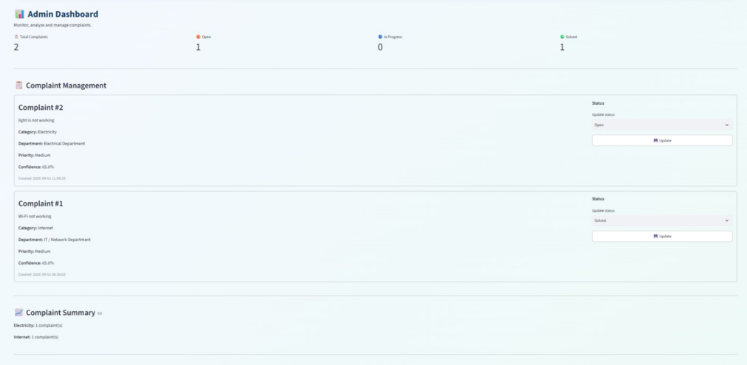
Figure 4.3 – Administrator Dashboard and Complaint Management

OUTPUTS
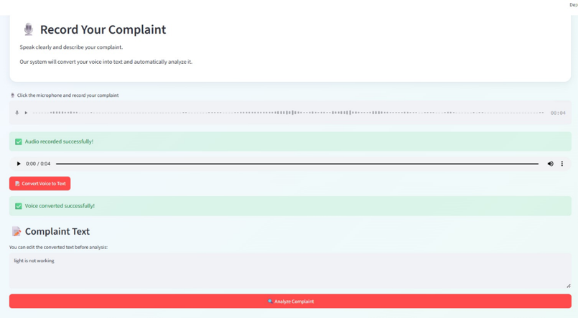

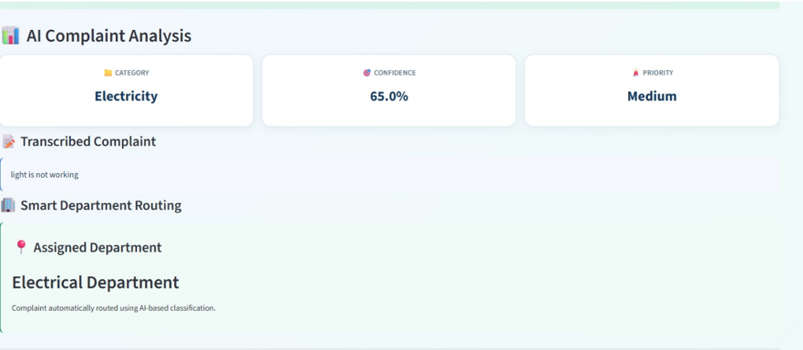

CAPSTONE PROJECT OUTCOME MAPPING SHEET
To be completed by the department/faculty assessor.
Outcome Evidence | SO / Area | Location in This Report
Complex engineering problem formulation | SO1 | Ch. 1, Ch. 2
Engineering design under constraints | SO2 | Ch. 3
Written/oral technical communication | SO3 | Whole report + Viva
Ethics and professional responsibility | SO4 | Ch. 3 (3.8)
Teamwork and leadership | SO5 | Ch. 4 (4.8)
Experimentation, analysis, engineering judgment | SO6 | Ch. 4 (4.3–4.6)
Independent acquisition of new knowledge | SO7 | Ch. 5 (5.3)
Standards | SO2 | Ch. 3 (3.2)
Sustainability and societal/environmental impact | SO2/SO4 | Ch. 3 (3.8)
Risk assessment and mitigation | SO2/SO4 | Ch. 3 (3.9)
Security considerations | Relevant SO | Ch. 3 (3.8)
Integrated/system-level engineering | SO1/SO2 | Ch. 3 (3.3–3.5)
Project planning and management | SO5 | Ch. 4 (4.8)
Individual contribution | SO1–SO7 | Contribution Statement + Ch. 4

